A Knowledge Graph for Colon Adenocarcinoma
Drashti Bharat Bhanushali
BIOT 6900 – AI-Powered Biotech Workflows · Module 7 Assignment
2 November 2026
My disease is colon adenocarcinoma (COAD). I have used it since Module 2. The graph runs on a Neo4j AuraDB Free instance. It has 54 nodes and 61 relationships: 18 genes (15 for COAD, 3 for the related disease), 2 diseases, 5 phenotypes, 9 pathways, 13 drugs and 7 variants. A script called prepare_kg_data.py builds the gene evidence from my own earlier outputs, so every number on a gene node can be traced back to a module.
The graph answers the opening question well. The centrality ranking is less useful than it looks. It mostly measures how many drugs and variants I attached to each gene, not how important the gene is.
1. Schema and evidence
I used the same six node types as the worked example. Each type is a step in the question the graph has to answer: which drugs act on genes linked to my disease, and which drugs for a similar disease might be worth a look?
Node | n | What it carries | Where it comes from
Gene | 18 | Ensembl ID, GWAS p, RNA log2FC, protein log2FC, druggability | Modules 2, 3 and 6
Disease | 2 | name | COAD and ulcerative colitis
Phenotype | 5 | name (HPO term) | HPO
Pathway | 9 | name | Reactome-style groupings
Drug | 13 | approval status | ChEMBL mechanism of action
Variant | 7 | name | Module 6 GWAS SNPs, Module 2 somatic hotspots
Table 1. Node types in the graph.
I left out the optional patient layer. My only real cohort is from Module 6, and its phenotype is simulated. Adding it would make the graph look like it held clinical data when it does not.
I picked the 15 COAD genes so that every kind of evidence from Part I is in the graph. I did not just take the top 15 of one list.
- Multi-omics (Module 2), 4 genes: CA2, DES, CR2 and MYH11. These are my strongest RNA and protein genes (CA2 RNA −5.20, protein −2.16). All four are lower in tumour.
- Somatic drivers (Module 2 CPTAC), 2 genes: KRAS (mutated in 35 of 106 tumours) and BRAF (18 of 106). Both are significant on the mutation layer. None of my top multi-omics genes were.
- Approved COAD drug targets, 5 genes: EGFR, VEGFA, TYMS, TOP1 and PTGS2. I added these because my own genes are all down in tumour. Without drug targets, the 2-hop query would only find drugs for down-regulated genes, which is the wrong direction.
- Germline GWAS loci (Module 6 PRS), 4 genes: MYC (rs6983267, p = 2 × 10⁻¹²²), SMAD7 (rs4939827, 3 × 10⁻³⁰), TCF7L2 (rs11196172, 7 × 10⁻²⁰) and BMP4 (rs4444235, 8 × 10⁻¹⁰). Each p-value is the best colorectal-cancer association for that SNP in the GWAS Catalog.
The druggability number on each gene is my Module 3 tractability prior, max(p_{sm}, p_{ab}). I refit it with every graph gene held out of training. I then checked it against my published Module 3 numbers: CA2 0.769 vs 0.770, DES 0.001 vs 0.001, CR2 0.640 vs 0.663.
Every edge carries a type, a source and a confidence level. Gene-to-disease edges also carry a p-value where one exists.
Relationship | n | source values | confidence | Other property
Gene –ASSOCIATED_WITH→ Disease | 18 | multi-omics (TCGA/CPTAC), somatic mutation (CPTAC), pharmacology, GWAS Catalog | high / medium / low | pvalue (GWAS genes)
Disease –HAS_PHENOTYPE→ Phenotype | 8 | HPO | low | —
Gene –PARTICIPATES_IN→ Pathway | 15 | Reactome | low | —
Drug –TARGETS→ Gene | 13 | ChEMBL | high | drug status on the node
Variant –OCCURS_IN→ Gene | 7 | GWAS Catalog (Module 6 PRS), CPTAC somatic (Module 2) | high (somatic) / low (GWAS) | —
Table 2. Relationship types and the evidence stored on each edge. The confidence levels come from the ranking in Section 4.
The source matters most on the 18 gene-to-disease edges, because those edges hold four very different kinds of claim. “This protein drops 4-fold in tumour” is not the same kind of evidence as “a COAD drug targets this gene”. The source label is the only thing that tells them apart in a query.
The assignment asks for variants from Module 5. My Module 5 gene was CYP2C19, which is a drug-metabolism gene with no link to colon cancer. So I used two sources about my own disease instead. Four variants are COAD GWAS lead SNPs from my Module 6 score. Three are somatic hotspots I counted in the Module 2 CPTAC tumours: KRAS G12D (11 of 106), KRAS G12C (2 of 106) and BRAF V600E (13 of 106).
For identifiers, every gene enters as an HGNC symbol from my Module 3 proteome table (UniProt release 2026_03), with that table's Ensembl ID attached. Neo4j has a uniqueness constraint on name, and I load nodes with MERGE. So re-running the notebook cannot create a second copy of a gene. One thing could still go wrong: for a GWAS SNP, the gene the Catalog maps is sometimes not the gene I attached. For example, rs6983267 maps to CASC8/CCAT2, but MYC is the gene it is thought to regulate. In those cases I attached the literature candidate gene and saved the Catalog's mapped genes in data/targets_coad.csv, so my choice is visible.
2. Top targets
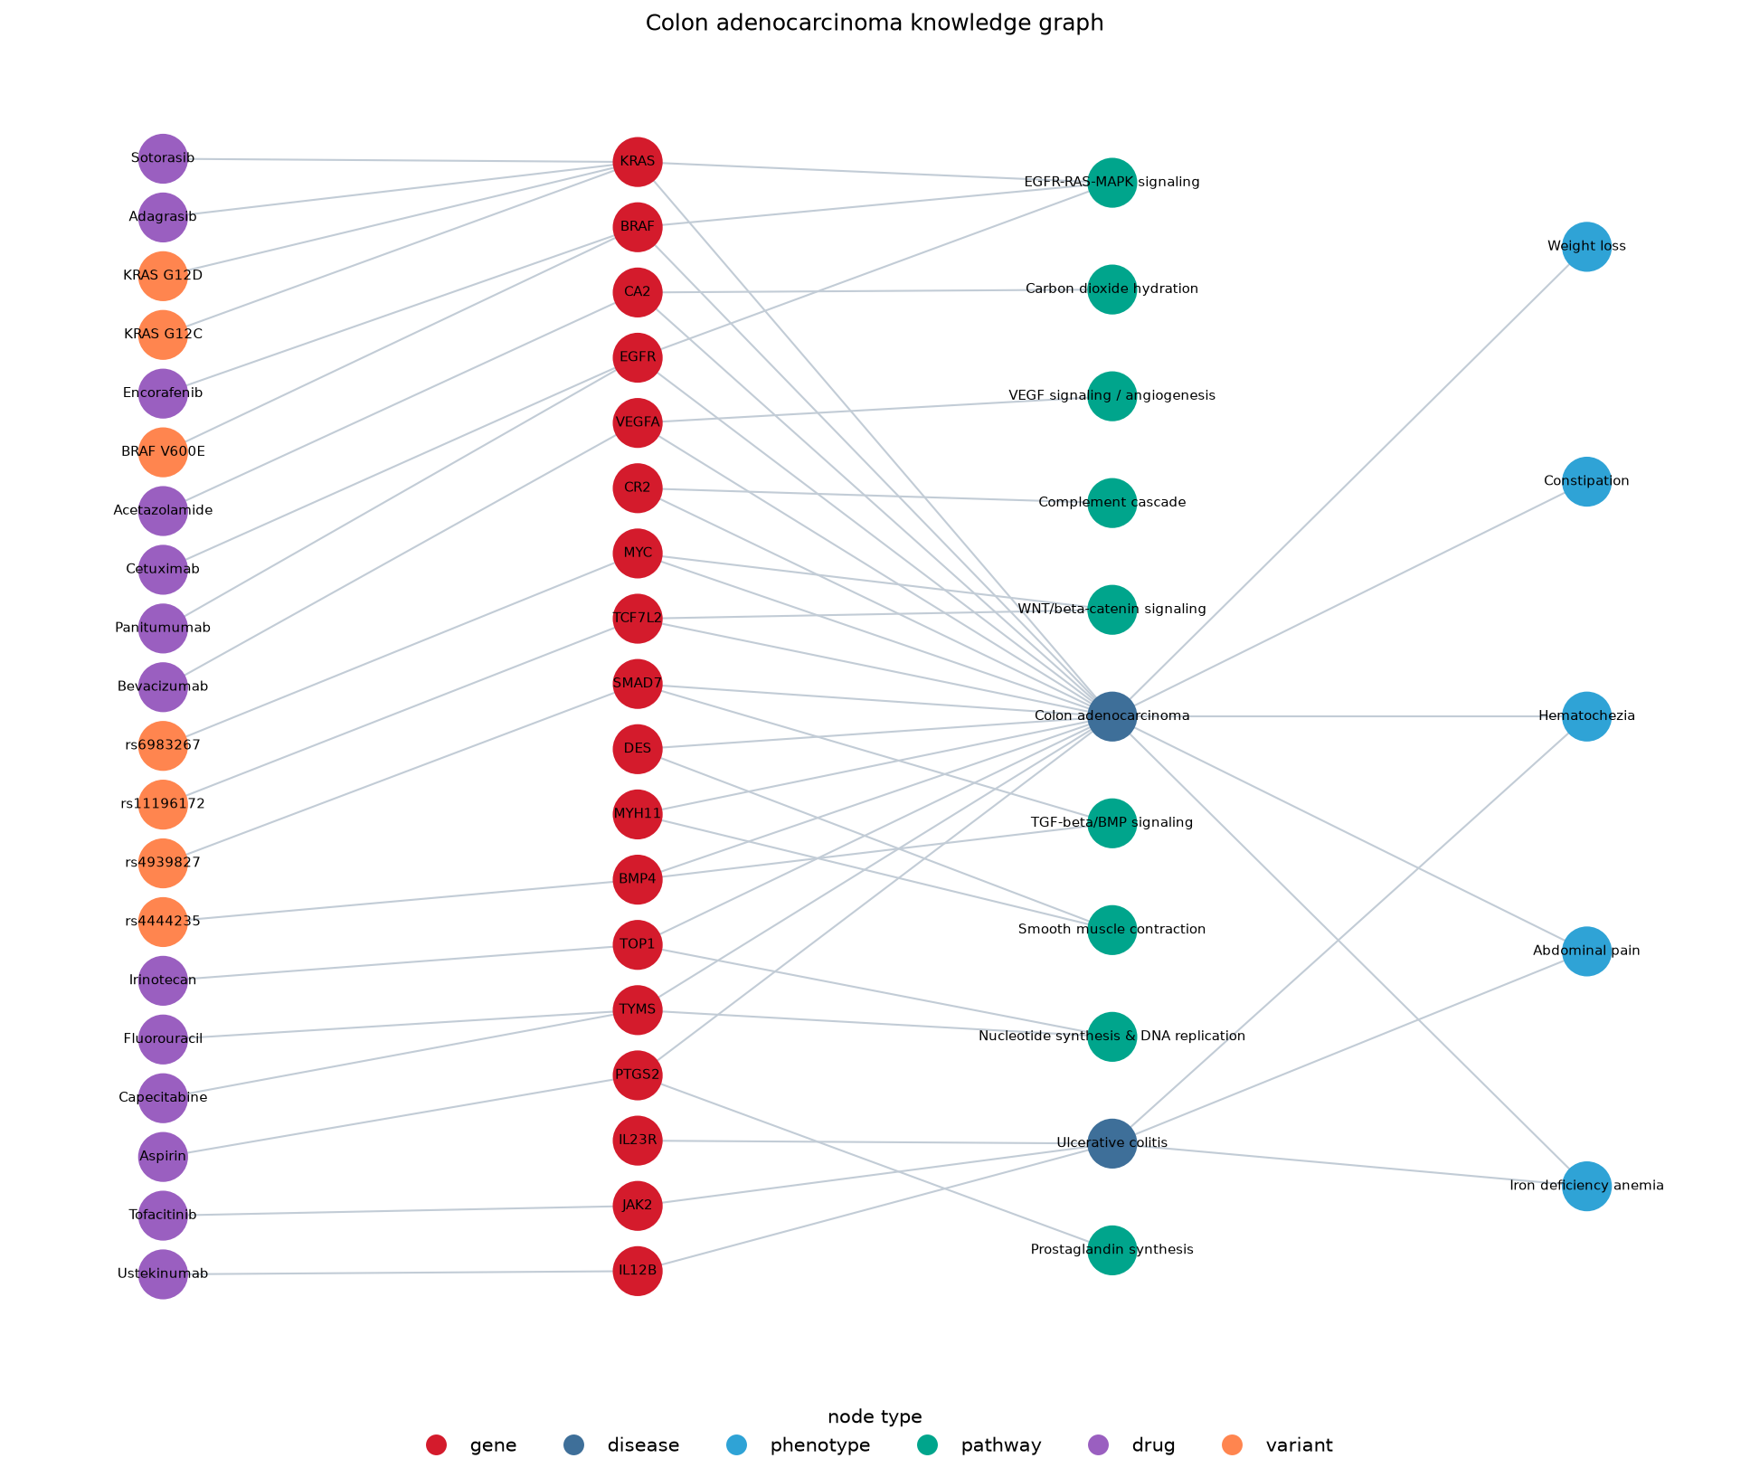
Figure 1. The colon adenocarcinoma knowledge graph (54 nodes, 61 edges), exported from the notebook as my_knowledge_graph.png. It is drawn in layers that follow the edge directions: drugs and variants (left) point to genes, genes connect to diseases and pathways, and diseases connect to phenotypes (right). Node colour shows node type (legend below the graph). Ulcerative colitis (lower middle) is the related disease behind the repurposing query in Section 3. The node and edge tables are exported alongside it as nodes.csv and edges.csv.
Rank | Gene | PageRank | Evidence type | Druggability
1 | KRAS | 0.0377 | somatic mutation | 0.50
2= | BRAF | 0.0231 | somatic mutation | 0.69
2= | EGFR | 0.0231 | pharmacology | 0.71
2= | TYMS | 0.0231 | pharmacology | 0.09
5= | CA2, MYC, SMAD7, TCF7L2, BMP4, TOP1, PTGS2, VEGFA | 0.0158 | mixed | 0.02–0.77
last | DES, MYH11, CR2 | 0.0086 | multi-omics | 0.00–0.64
Table 3. Candidate biomarker ranking. PageRank fused with the gene evidence.
The top three match the biology. KRAS, BRAF and EGFR are central to how COAD is treated. RAS and BRAF status decide whether a patient gets anti-EGFR antibodies, and the KRAS G12C and BRAF V600E inhibitors are approved for these tumours. A clinician would pick the same three genes.
But they are on top because of my schema, not because of the biology. In a directed graph, a gene only gains PageRank from edges that point into it. The only edges pointing into my genes come from drugs and variants. KRAS is first because two drugs and two variants point at it. Any gene with no drug and no variant sits at the floor value of 0.0086. So the ranking really measures how many drugs and variants I attached, and I chose those myself.
Three results stand out.
- TYMS ties for second, even though its COAD evidence is weak (RNA +0.85, no protein measurement), its druggability prior is only 0.09, and it has no GWAS signal. It ranks that high only because two drugs point at it, fluorouracil and capecitabine. TYMS is a chemotherapy target and is needed by any dividing cell, so it is not really a COAD biomarker. This is the clearest case of the graph rewarding pharmacology instead of disease biology.
- MYC has the strongest genetic evidence in the graph but only ranks mid-table. Its p-value of 2 × 10⁻¹²² is over a hundred orders of magnitude stronger than BMP4's, but the two score the same. PageRank never looks at the p-value. My table shows PageRank and evidence side by side instead of combining them into one number.
- My best Part I genes rank last. CA2 is mid-table only because I attached acetazolamide from Module 4. DES, MYH11 and CR2 had some of the strongest RNA-and-protein evidence in my whole Module 2 analysis, but they sit at the floor value. That makes sense: they are down in tumour, and nobody has made a drug against them.
Community detection put DES, MYH11 and CR2 in one cluster with the COAD node, the “Smooth muscle contraction” and “Complement cascade” pathways, and two symptoms. I think this cluster is about tissue composition, not about how the tumour works. DES and MYH11 are smooth-muscle proteins. Normal colon samples contain muscle and stroma, while tumour samples are mostly epithelium. So these genes look “lost in tumour” partly because the normal samples simply contain more muscle. CR2 is a receptor on B cells and follicular dendritic cells, which points to lymphoid tissue in normal mucosa. Read this way, the cluster is a warning about my Module 2 ranking rather than a COAD subtype.
3. A hypothesis from a path
The 2-hop query returned the approved COAD drugs that act on genes in my graph: cetuximab and panitumumab through EGFR, bevacizumab through VEGFA, fluorouracil and capecitabine through TYMS, irinotecan through TOP1, sotorasib through KRAS and encorafenib through BRAF.
The shared-symptom query then returned two repurposing candidates from ulcerative colitis. Here is one full path from the notebook:
Ustekinumab –TARGETS [ChEMBL]→ IL12B –ASSOCIATED_WITH [GWAS Catalog, p = 1 × 10⁻²¹]→ Ulcerative colitis –HAS_PHENOTYPE [HPO]→ Iron deficiency anaemia ←HAS_PHENOTYPE [HPO]– Colon adenocarcinoma
The second candidate was tofacitinib through JAK2, by the same route. Both paths go through all three shared symptoms: rectal bleeding, abdominal pain and anaemia.
The path is weak, and I want to say that before giving the hypothesis. The two diseases are only linked by three symptoms that hundreds of bowel conditions share. Taken literally, the path would suggest a UC drug for any disease that makes people bleed. So I treat the path as a pointer, and I take the actual hypothesis from the biology of the gene at the end of it.
IL12B codes for p40. This subunit is shared by IL-12 and IL-23. IL-23 signalling is a known driver of gut inflammation, and UC itself raises colorectal cancer risk. My hypothesis is that blocking IL-23 reduces the growth of colorectal tumours that start on an inflammatory background. The graph found this through symptoms, but the real argument is the IL-23 to IL-17 inflammation axis that UC and colitis-associated cancer share.
There is a problem the graph cannot see. Ustekinumab blocks p40, so it blocks IL-12 as well, and IL-12 helps the immune system attack tumours. A p40 blocker could therefore help through IL-23 and hurt through IL-12. A drug that blocks only the IL-23-specific p19 subunit (IL23A), such as mirikizumab or guselkumab, would be a cleaner test. IL23A is not in my graph, so the graph could not have suggested it.
I would test the hypothesis in three steps, cheapest first.
- Check expression in data I already have. In TCGA-COAD, compare an IL-23/IL-17 signature (IL23A, IL12B, IL23R, IL17A) between tumour and normal, and against survival. If there is no difference, the idea is weak before any lab work starts.
- Run a retrospective cohort. In UC patient records, compare how often colorectal neoplasia appears in patients on IL-23 drugs versus patients on anti-TNF drugs. This needs a careful design, such as target-trial emulation, because sicker patients tend to get the newer drugs.
- Use a mouse model. Run the AOM/DSS colitis-associated cancer model with three arms: anti-p40, anti-p19 and a control antibody. Count tumours and measure IL-17 in the tissue. If anti-p19 works better than anti-p40, my IL-12 worry was real.
4. An edge is evidence, not truth
Here are my edge types from weakest to strongest, and what better data would change. These rankings are what the confidence values in Table 2 record.
1. Gene-to-disease edges with source “pharmacology” (5 edges). These are the weakest, and they are circular. I linked EGFR, VEGFA, TYMS, TOP1 and PTGS2 to COAD because a COAD drug targets them. So when the 2-hop query reports that COAD drugs act on COAD genes, part of that answer is something I put in myself. These edges also drive the ranking in Section 2. With better data I would replace them with Open Targets association scores, which combine genetics, expression and literature. I would expect TYMS and TOP1 to drop out, and only genes with independent disease evidence to keep their edges.
2. Phenotype edges (8 edges). I typed these in by hand from the HPO term list instead of pulling them from the HPO disease annotation file. All five COAD phenotypes are very general. My whole repurposing result passes through these edges. With better data I would use the HPO annotations, or more specific phenotypes such as colonic adenoma and chronic mucosal inflammation. UC would probably still connect through inflammation, but the symptom-only paths would disappear.
3. Variant-to-gene edges for GWAS SNPs (4 edges). The name OCCURS_IN is simply wrong for at least two of them. rs6983267 sits in an enhancer that the Catalog maps to CASC8/CCAT2, and rs4444235 maps to DDHD1-DT/MIR5580, near BMP4. I attached the literature candidate gene in both cases. With better data, colocalisation with colon eQTLs or fine-mapping would show which gene each SNP really acts on. The edge should also be called REGULATES, not OCCURS_IN, for SNPs outside the coding region.
4. Pathway edges (15 edges). I labelled these Reactome, but they are my own simplified groupings, and four of my nine pathways contain only one gene. Real Reactome membership is much larger. MYC, for example, sits downstream of EGFR-RAS-MAPK signalling as well as WNT. With better data, full Reactome membership would merge several of my communities. The neat one-pathway-one-cluster picture in Section 2 is partly an artefact of how sparse I kept this layer.
5. Multi-omics gene-to-disease edges (4 edges). The measurements are real and highly significant, but Section 2 shows what they may really be measuring, which is tissue composition. The RNA (TCGA) and protein (CPTAC) layers also come from different patients. With better data, deconvolved or single-cell expression would separate real epithelial loss from changes in how much muscle and stroma a sample contains. I would expect DES and MYH11 to lose their edges.
6. Drug-to-target and somatic-variant edges. These are the strongest. Drug mechanisms are well established, and I counted the hotspots straight from the CPTAC mutation table. The one catch is direction: acetazolamide inhibits CA2, but CA2 is lost in tumour (Module 4 and Deliverable 1). The edge is true and still not useful for therapy.
One problem runs through the whole graph: every edge counts the same. PageRank treats a pathway edge I typed in by hand exactly like a GWAS hit at 10⁻¹²². The fix, using the same graph, is a weighted PageRank with weights taken from the evidence, such as −log₁₀ p for genetic edges and Open Targets scores for association edges. I would expect MYC and SMAD7 to rise and TYMS to fall.
I used an AI assistant (Claude) to assemble the gene table and write prepare_kg_data.py, which pulls from my Module 2, 3 and 6 files and the GWAS Catalog API. I checked its output four ways:
- I reproduced my published Module 3 priors to within 0.03.
- I made the GWAS lookup accept only single-disease studies. The first version had picked up a JAK2 p-value from a pooled five-disease study.
- I counted the KRAS and BRAF hotspots myself, directly from the CPTAC mutation table.
- I checked that the node and edge counts in Neo4j, 54 and 61, match what the notebook built.
The Cypher queries are the ones provided, plus one path query that I checked by reading its output path edge by edge.

